Multiple choice section – choose the correct answer

Questions 1 to 3 refer to the following diagram.

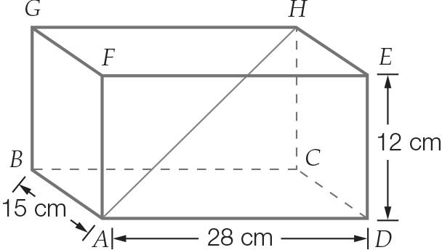

Question 1 [7.1]

The distance from A to C is closest to:

A 30 cm B 19 cm C 43 cm D 32 cm

Question 2 [7.1]

The distance from A to H is closest to:

A 34 cm B 35 cm C 30 cm D 45 cm

Question 3 [7.1]

The angle formed at the base, between lengths CA and HA, is closest to:

A 45 B 20 C 28 D 52

Question 4 [7.2]

The equivalent trigonometric ratio in quadrant 1 of sin (212) is:

A −sin (32) B −sin (58) C sin (32) D sin (58)

Question 5 [7.2]

The amplitude and period respectively of the graph is:

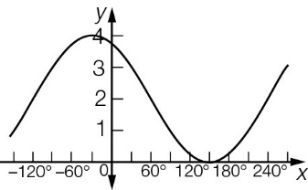

A 2, 120 B 2, 360 C 4, 120 D 4, 360

Question 6 [7.3]

The solution to 5 + 10 cos (x) = 0 for 180 ≤ x ≤ 360 is:

A 210 B 240 C 300 D 330

Question 7 [7.4]

A triangular shade is erected over a sandpit between posts as shown below. The distance between the posts along the side marked x is:

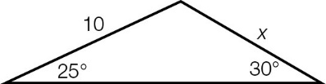

A 5 sin (25) B 10 sin (30) C 20 sin (30) D 20 sin (25)

Question 8 [7.6]

The area of the triangle is:

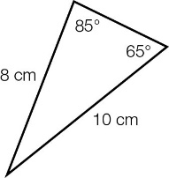

A 20 cm2 B 36 cm2 C 15 cm2 D 40 cm2

Multiple-choice total marks: ___ / 8

Short answer section

Question 9 4 marks [7.1]

In the wedge shown:

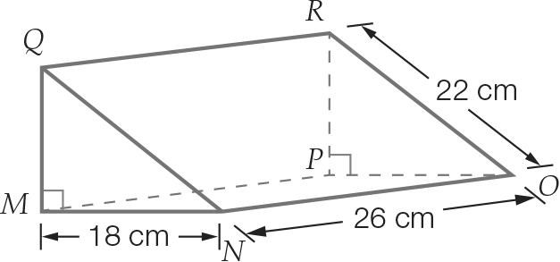

(a) Calculate the distance between N and P. Round your answer to 1 decimal place.

(b) Calculate the distance between N and R. Round your answer to 1 decimal place.

(c) Calculate the height, PR, of the wedge. Round your answer to 1 decimal place.

(d) Calculate angle QNM, rounded to the nearest degree.

Question 10 2 marks [7.1]

What angle, correct to 2 decimal places, does the diagonal make with the base of the prism?

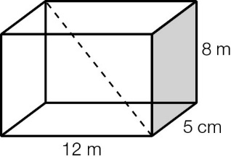

Question 11 2 marks [7.1]

The maximum possible length of a drinking straw is inserted into a cylindrical soft drink can of height 19 cm. If 21 cm of the straw is inside the can, what angle does the straw make with the base? Give your answer correct to 2 decimal places.

Question 12 3 marks [7.2]

For each of the following, find the equivalent trigonometric ratio in the first quadrant of:

(a) cos (158)

(b) tan (217)

(c) sin (332)

Question 13 2 marks [7.2]

The trigonometric ratio cos (φ) is equivalent to −cos (62). Find two values for the angle φ for 0 ≤ φ ≤ 360 that will produce this result.

Question 14 2 marks [7.2]

For the trigonometric relationship in the graph, State the:

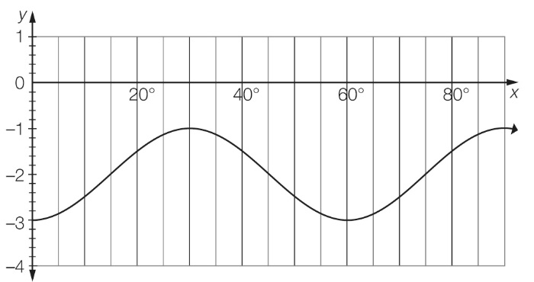

(a) period

(b) amplitude.

Question 15 2 marks [7.3]

In which quadrants are the solutions for the equation 3 + 5 cos (x) = 0 for 0 ≤ x ≤ 360?

Question 16 4 marks [7.3]

Find all solutions to the equation 5 sin (θ) + 2 = 0. Write your answers correct to  
2 decimal places.

Question 17 2 marks [7.4]

Calculate the length of the side labelled *x*. Leave your answer in terms of θ.

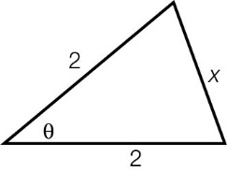

Question 18 4 marks [7.4]

In , , XZ = 8 m and YZ = 6 m.

(a) Draw a diagram to represent this triangle.

(b) Calculate  correct to the nearest degree.

(c) Calculate the third angle, correct to the nearest degree.

(d) Calculate the third side length, correct to the nearest metre.

Question 19 4 marks [7.4]

If a = 5x, b = 4x, and c = 2x, what is the value of the angle θ in the cosine formula ? Give your answer correct to 2 decimal places.

Question 20 4 marks [7.5]

An aircraft descends at an angle of depression of 19 from point A for a distance of 34 km to point B. It then flies horizontally for a further 28 km to point C.

(a) Draw a diagram to represent this scenario.

(b) How many metres, correct to the nearest whole number, would be saved if the aircraft flies directly from A to C?

Question 21 3 marks [7.6]

A park is to be created in a new suburb. The park is to lie between Tan St, Sine Avenue and The Great Cosine Highway. If Tan St runs in a north-east direction for 1.6 km until it reaches Sine Avenue, Rose Avenue runs another 2.2 km on a bearing of 145T until it reaches The Great Cosine Highway and The Great Cosine Highway connects to the start of Tan St, what area is to be covered by the park? Give your answer correct to 2 decimal places.

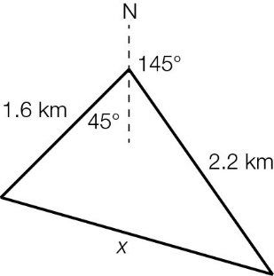

Question 22 4 marks [7.6]

The lengths of the adjacent sides to acute angle θ in a triangle are 4a and 6a. If the triangle’s area is square units, find the value of θ.

Short answer total marks: ___ / 42

Extended response section

Question 23 12 marks [7.1, 7.4, 7.5, 7.6]

A driveway is to be built on a sloping block of land so that the left edge of the driveway will reach the left side of a garage a horizontal distance of 12 m from the front boundary and 9 m to the left of the front boundary entrance. If the land has a uniformly upward slope of 35 to the horizontal, find, correct to 2 decimal places the:

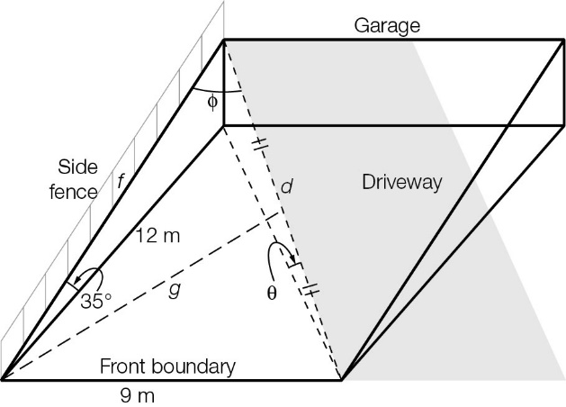

(a) the length, d, of the driveway

(b) the angle of inclination, θ, of the driveway to the horizontal

(c) the length, f, of side fencing that would be needed from the front boundary to the left side of the garage if the garage is built to the side edge of the land (assume a rectangular block of land)

(d) the angle, φ, between the side fence and the driveway

(e) the area of a triangular garden to be planted if it is bounded on one side by the side fence and on another side by the top half of the left edge of the driveway

(f) the length, g, of the third side of the triangular garden area.

Question 24 8 marks [7.2. 7.3]

The graph shows the water level (y metres) of the sea above a high tide/low tide marker on the pier over a period of 24 hours (x-axis). The value corresponds to 4 am Sunday.

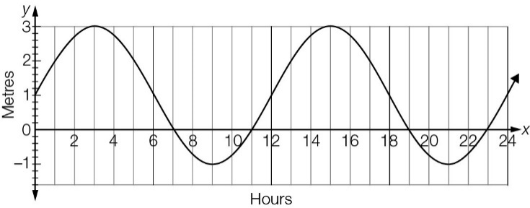

(a) Write the period and the amplitude.

(b) When is high tide during the first 12 hours?

(c) Given that the equation of the graph is y = 2 sin (30x) + 1, find the times, in hours, that the water was at the 2.5 m marker.

(d) Hence, what is the total time the water was below the 2.5 m marker in this 24-hour period?

Extended answer total marks: ___ / 20

TOTAL test marks: ___ / 70